SETBACK & CONSTRUCTION PERMIT APPLICATION
CENTRE TOWNSHIP
2971 Cold Storage Road, New Bloomfield, PA 17068
717-582-8784

Permit No.____________________ Tax Parcel No._____________________________________
Applicant: ______________________________________________________ Phone: _____________________________________
Owner: _________________________________________________________ Phone: ____________________________________
Address: ___________________________________________________________________________________________________
Contractor: _______________________________________________________________________ Phone #__________________
Construction Location: ______________________________________ Sub-Div Name: _______________________ Lot#: ________
Brief Description of Proposed Work: ____________________________________________________________________________
Lot Size: Front ______ft. Rear ______ft. R. Side ______ft L. Side ______ft.
Building Setbacks: Front ______ft. (50’ Min off of Road ROW) Rear ______ft. (25’ Min) R. Side _____ft. (15’ Min) L. Side _____ft. (15’ Min)
Type of Improvement: New Construction______ Addition______ Improvement to Existing Building____ Other____________
Intended Use: Residential_____ Agricultural _____ Apartment(s)_____ Commercial_____ Industrial____ Other__________
Type of Business or Industry: ____________________________________________ Do you have required State Permits? _______
Size of Building: Length ________ft. Width ________ft. Height ________ft. # of Stories: ________
Basement: Yes____ No____ Garage: Att_______Det ________ Central Air: Yes____ No____ Type of Heating: _____________
Number of Bedrooms: ______ Fireplaces: ______ Front Porch: ______ Rear Porch: ______ Deck(s): ______
Wall Construction: Frame_____ Siding_____ Brick _____ Stone_____ Metal_____ Other _________________
Type of Water Supply: Private_____ Public _____ Type of Sewage System: Private_____ Public _____
If Mobile Home: Length _____ft. Width _____ft. Year ______ Make ________________ Color __________________
Total Estimated Cost of Improvement: $______________________ (Include Labor and Materials at current market value)
A SITE PLAN WITH DETAILS MUST BE SUBMITTED WITH APPLICATION
___________________________________________________________________________________________________________________________________________________________
Stormwater/Other Permits:
Amount of Earth to be Disturbed: ________________________Sf. (Disturbance greater than 5,000 sf. requires an E and S Plan)
(Disturbance greater than 1.0 acre requires an NPDES permit)
Type of SWM required: ___________________ SWM Fee: $________________ Fee determined by type of SWM required - see page 2
Other Applicable Permits: Type: _____________#: ________ Sewage Permit #: ___________ Driveway Permit #: __________
--------------------------------------------------------------------------------------------------------------------------------------------------------------------------------
Permit Fees: $ ________________ ($5.00 for first $1,000 and $2.00 for each add’l $1,000 + SWM Fee) Check/Money Order #: ______________
Received by: ________________________ Permit Issue Date: ___________ Expiration Date: ____________
Permit Denied Date: ______________ Reason: ______________________________________ Section #: __________________
--------------------------------------------------------------------------------------------------------------------------------------------------------------------------------
Applicant’s Signature: _________________________________________________ Date: ________________
(Two Board Member’s signatures are required before starting any construction)
Township Supervisor's Signature ____________________________________
Township Supervisor's Signature ____________________________________
PERMIT IS VOID IF CONSTRUCTION IS NOT STARTED WITHIN 6 MONTHS.

Permit No: ______________________
Municipality: Centre Township, Perry County
Application for Stormwater Management Review
Centre Township, Perry County, PA

General Information:
Owner / Applicant's Name: _______________________________________
Address: ______________________________________________________
______________________________________________________
Telephone Number: ___________________________ Email:____________________________________
Engineer/Surveyor Name: ___________________________________________________________
Address: _____________________________________________________________
Telephone Number: __________________________ Email_____________________________________

Site Information:
Address of Property: _____________________________________________________
_____________________________________________________
Tax Map Parcel ID#: __________________________Parcel Size (approx.) ______________________

A Sketch Plan must be included and show the following:
- Total existing impervious area on the property: ____________________
- New impervious area proposed: ____________________
- Total impervious area on the property after
project completion: ____________________
- Slopes, flow path, locations, distances, etc.: ____________________
- Are there any known existing drainage problems or the potential for the proposed project to create drainage problems? ___No ___Yes (if yes, please explain___________________________________

To be completed by authorized municipal official
Type of Stormwater Management Required: Initial Fee
- Application with impervious area less than 1000 sf [___] $100.00*
- Application with impervious area that is 1,001 – 10,000 sf [___] $145.00*
and meets the disconnect
- Application with impervious area that is 1,001 – 10,000 sf [___] $485.00*
and does not meet the disconnect
*Engineer’s fee assumes one review and one site visit/inspection. Additional reviews and inspections as required will be charged in addition to these fees.
SWM Type determined by: _________________________________ Date: ___________________
*Based on information provided on this Application and a Sketch Plan received on: __________________________

STORM WATER MANAGEMENT PERMIT
REGULATED ACTIVITY
Centre Township
Perry County, Pennsylvania
PERMIT NO. ________________
The property of: _____________________________________________________________________
located at: _________________________________________________________________________
has received approval of the storm water management plans dated _____________________
last revised ________________________, in accordance with the Centre Township Storm Water
Management Ordinance. Inspections are required as outlined below.
Approved By: __________________________________
Township Engineer
Date: _________________
Expiration Date: _________________ (5-year maximum)
[ __ ] Owner Acknowledgment Executed
[ __ ] Operation and Maintenance Agreement Executed
[ __ ] Financial Guarantee Established per Section 503
[ __ ] Fees Paid & Construction Inspection Escrow Established
[ __ ] Permit Issued*
SCHEDULE OF INSPECTIONS (Per Section 602, 407 & 802)
(Review fees apply in accordance with Section 601)
Approved Date During construction of the following specific Stormwater Management facilities:

o Final grading, vegetative control measures, or other site restoration work.
o As-Built Plan (when necessary)
o Project completed – Financial Guarantees recommended to be released.

Municipal Stormwater Management Worksheet

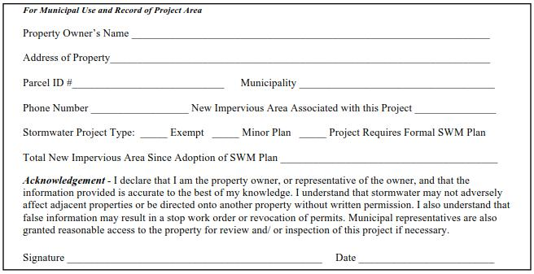

Step 1: Determine the amount of new impervious area created by the proposed project. This includes any new surface areas that prevent infiltration of stormwater into the ground. New stone and gravel areas are considered impervious. Impervious areas existing before May 15, 2019 are not included in this calculation. Use additional sheets if necessary.

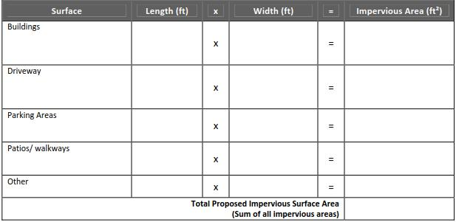
Calculate new impervious area by completing this table.

If the total new impervious surface area is up to 1,000 ft2, the project is exempt from the requirement to submit a plan for approval. Sign Acknowledgement and file this sheet with municipality.

If the total impervious surface area is 1,001 ft2 to 10,000 ft2, continue to Step 2.

  - If project area can be entirely disconnected, sign Acknowledgement, demonstrate disconnection on site plan per DIA example, and file worksheets with municipality.

  - If project is between 1,000 ft² and 5,000 ft² and requires BMPs, complete Step 3.
  - If project area is 5,000 ft² – 10,000 ft² and can’t be disconnected, the project does not qualify for the Simplified
Approach.

Perry County, Pennsylvania

Municipal Stormwater Management Worksheet

Step 2: Determine Disconnected Impervious Area (DIA). All or parts of proposed impervious surfaces may qualify as Disconnected Impervious Area if runoff is directed to a pervious area that allows for infiltration, filtration, and increased time of concentration. The volume of stormwater that needs to be managed could be reduced through DIA. Prepare a minor stormwater site plan (see page C-4 for requirements).
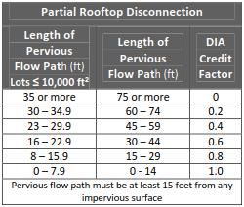

Criteria
Overland flow path from the discharge area or impervious area
has a positive slope of 5% or less.
Contributing area to each rooftop discharge (downspout) is 500
ft² or less.
Soils are not classified as hydrologic soil group “D”.
The receiving pervious area shall not include another person’s
property unless written permission has been obtained from the
affected property owner.

Paved Disconnection Criteria: Paved surfaces (driveways, walkways, etc.) and gravel can be considered disconnected if it means the criteria above and:
Runoff does not flow over impervious area for more than 75 ft.

The length of overland flow is greater than or equal to the contributing flow path.

The slope of the contributing impervious areas is 5% or less.

If discharge is concentrated at one or more discrete points, no more than 1,000 ft² may discharge to any one point. In addition, a gravel strip or other spreading device is required for concentrated discharges. Non-concentrated discharges along the entire edge of paved surface must include provisions for the establishment of vegetation along the paved edge and temporary stabilization of the area until the vegetation is established.

If these criteria can be met, the DIA credit = 0.

Using the calculations from Step 1, complete the table below. This will determine the impervious area that may be excluded from the area that needs to be managed through stormwater BMPs. If the total impervious area to be managed = 0, the area can be considered entirely disconnected.
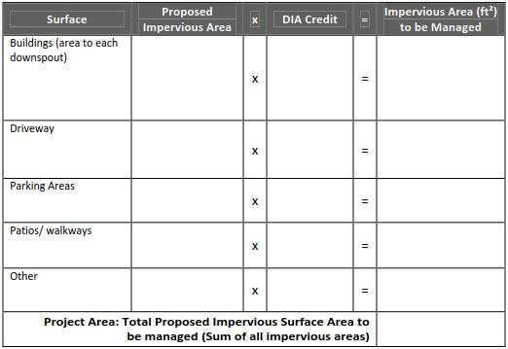

If total surface area to be managed if greater than 0, continue to Step 3.

Perry County, Pennsylvania

Municipal Stormwater Management Worksheet

Step 3: Calculate the volume of stormwater runoff created by proposed impervious surfaces or see Simple BMP Sizing in Step 4.
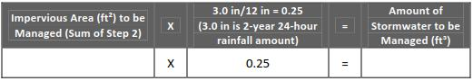

Best Management Practices need to be used to manage the volume of stormwater created by the proposed impervious areas. The cubic feet of stormwater that need to be managed may also be further reduced by planting new trees. If the criteria below can be met, the amount of stormwater to be managed can be reduced per the following:

Deciduous Trees = 6ft³ per tree Evergreen Tree = 10 ft³ per tree

Criteria:
Trees must be PA native species (See PA Stormwater BMP Manual for a list)

Trees shall be a minimum 1” caliper tree and 3 feet tall shrub (min)

Trees shall be adequately protected during construction

No more than 25% of the required capture volume can be mitigated through the use of trees Dead trees shall be replaced by the property owner within 12 months

Please consider the specifications for each tree species when determining location and spacing
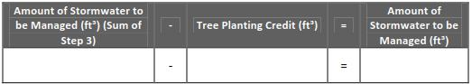

Step 4: Select BMP and size according to the volume of stormwater that needs to be managed. The Guide to Choosing Stormwater BMPs, included in the Simplified Approach, includes sizing calculations for specific techniques. Simple BMP Sizing – Sizing BMPs may also be simplified through the use of this chart. Take the sum of Step 2 and match it to the “Amount of New Impervious Area to be Managed” in white boxes in the table below (rounding up to the next value if the number is between two values). Then look in the light grey box to determine the cubic footage based on the type of BMP (bioretention or infiltration). For example, if a proposed 1,000 square foot impervious area must handle 240 cubic feet of stormwater in a bioretention system, a 13’x13’x1.5’ rain garden or a 36’x2’x3.5’ vegetated swale could be used. Show the location and size of proposed BMPs on the minor stormwater site plan. (The following was based on a chart from the Lycoming Co. Planning Dept.)
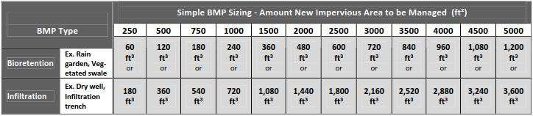

Bring the worksheets, plan, Owner Acknowledgement, and BMP Facilities and Maintenance Agreement (if applicable) to your municipality. If an area greater than 5,000 square feet of earth is disturbed, an erosion and sedimentation (E&S) control plan must be prepared. The municipality may require that the E&S plan be submitted to, reviewed, and approved by the Perry County Conservation District.

Perry County, Pennsylvania

Municipal Stormwater Management Worksheet

The minor stormwater site plan assists the owner/applicant in preparing the necessary information for the municipality to review and approve.

OWNER ACKNOWLEDGMENT

(Municipality may decide if the Owner Acknowledgement should be notarized and/or recorded, based on municipal process)

Development Activities shall begin only after the municipality approves the plan.

The installed BMPs will not adversely affect any property, septic systems, or drinking water wells on this or any other property.

If a stormwater management alternative to the approved minor stormwater site plan is used, the applicant will submit a revised plan to the municipality for approval. If a site requires a more complex system or if problems arise, the applicant may need the assistance of a licensed professional.

The applicant acknowledges that the proposed stormwater management BMPs will be a permanent fixture of the property that cannot be altered or removed without approval by the Township.

I (we) _________________________________________, hereby acknowledge the above

statements and agree to assume full responsibility for the implementation, construction, operation, and maintenance of the proposed stormwater management facilities. Furthermore, I (we) also acknowledge that the steps, assumptions, and the guidelines provided in this simplified approach package (minor stormwater site plan & Municipal Stormwater Worksheets(s)) will be adhered to.

Signature: __________________________________________ Date: _____________________

Signature: __________________________________________ Date: _____________________

Perry County, Pennsylvania
Centre Township Storm Water Management Process
Type of SWM Required

Depends on two factors
- Impervious coverage since May 15, 2019 __________________
- Amount of earth to be disturbed_______________________

An E and S plan is required for any disturbance greater than 5,000 sf. The property owner or excavator should have this plan on site and be implementing the measures shown on the plan.

Any disturbance greater than 1.0 acres requires an NPDES permit.

Any project with an impervious area of less than 1,000 sf is EXEMPT.
- Applicant must submit the worksheet and sign the acknowledgement – these must be filed with the township. Submit a check for the required fee.

Any project that meets the criteria for the disconnect with an impervious area greater than 1,000 sf and less than 10,000 sf must:
- Submit an application
- Submit a site plan demonstrating disconnect with drainage area to each discharge point and slope of receiving area.
- Submit the worksheets and sign the acknowledgement
- Submit a check for the required fee

Any project that does not meet the criteria for the disconnect with an impervious area greater than 1,000 sf and less than 5,000 sf requires Storm water BMPs and must:
- Submit an application
- Submit a site plan w/BMPs
- Submit the worksheets and sign the acknowledgement
- Submit the O and M agreement
- Financial security may be required.
- Submit an e and s plan to the PCCD for review and approval.
- Submit a check for the required fee

Any project that does not meet the criteria for the disconnect with an impervious area greater than 5,000 sf but less than 10,000 is not eligible for the simplified approach must:
- Submit a plan in accordance with the Centre Twp SWM Ordinance
- Submit an application.
- Submit a SWM plan, narrative and supporting calculations
- Submit an E and S plan to the PCCD for review and approval
- Sign and submit the acknowledgment letter
- Submit an O and M agreement
- Financial security may be required
- Submit a check for the required fee

Any project with a disturbed area greater than 1 acre regardless of impervious area must get an NPDES permit from PCCD and DEP and must:
- Submit an application
- Submit copies of the approved PCSM and E and S plans and supporting documents
- Sign and submit the acknowledgement letter
- Submit an O and M agreement
- Financial security may be required.
- Plans and agreement may be recorded.
- Submit a check for the required fee

