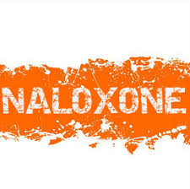  - Sponsored by Cumberland Perry Drug & Alcohol Commission  Naloxone & Recovery training  free community training  The RASE Project will be hosting a 2½ hour training workshop for community members on December 12, 2019 starting at 6:00 pm. This training will provide a brief overview of the science behind addiction & recovery. Attendees will also receive information about Naloxone and how to properly administer it. At the completion of the training, audience members will receive free Naloxone and a certificate of completion.  Pre-Registration Required:  Please email nataliey@raseproject.org  or call 717-249-6499  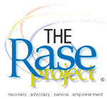 | Free Training for Community Members  ____  All Attendees will receive free Naloxone  ____  Naloxone saves lives  ____  Help Prevent Overdose Death in Your Community  ____  Learn What To Do After An Overdose  Madison Grange  777 Emory Green Rd  Loysville, PA 17047  December 12, 2019  6 pm

